Manufacturing Operational Insights Report (Project name - Academia)

  - Course Name: Devops

Institution Name: Medicaps University – Datagami Skill Based Course

Student Name(s) & Enrolment Number(s):
Sr no | Student Name | Enrolment Number
1 | Ashish Rana | EN21CA301016
2 | Jay Patidar | EN22IT301040
3 | Ravi Patidar | EN22IT301079
4 | Ujjawal Jain | EN22IT301114

Group Name: Group 06D12
Project Number: DO-44
Industry Mentor Name: Vaibhav
University Mentor Name: Prof. Akshay Saxena
Academic Year: 2022-2026

Problem Statement & Objectives -

- Problem Statement –

The primary objective of this project is to design, deploy, and manage an Online Education React application using Kubernetes in order to achieve a highly reliable, scalable, and efficient deployment system that meets modern application delivery requirements. This project aims to containerize the Online Education application using Docker, which allows the application along with all its dependencies, libraries, and configurations to be packaged into a single portable unit called a container. This ensures consistency across different environments such as development, testing, and production, and eliminates common issues related to environment mismatch. Another important objective is to deploy the containerized application onto a Kubernetes cluster using Minikube, which provides a powerful platform for automating the deployment, scheduling, and management of application containers. By using Kubernetes Deployment, the project ensures that multiple instances or replicas of the application are running at the same time, which improves the availability and reliability of the system and ensures that users can access the platform even if one or more instances fail. The project also aims to implement zero-downtime deployment using the Kubernetes Rolling Update strategy, which allows new versions of the application to be deployed gradually without stopping the existing running version, thereby ensuring that the service remains continuously available to users and that updates can be performed smoothly without affecting the user experience. Another objective is to expose the application using Kubernetes Service, which provides a stable network endpoint and allows users to access the application easily and reliably. In addition, the project focuses on improving the scalability of the system so that it can handle an increasing number of users efficiently by allowing the number of application instances to be increased or decreased based on demand, ensuring optimal performance and resource utilization. The project also aims to enhance fault tolerance and reliability by utilizing Kubernetes self-healing capabilities, which automatically detect failed containers and restart or replace them without manual intervention, ensuring continuous operation of the application. Furthermore, the project aims to implement automation and modern DevOps practices by integrating tools such as Git for version control and CI/CD tools like GitHub Actions or Jenkins for automated build and deployment, which reduces manual effort, minimizes human errors, and improves deployment speed and efficiency. Another important objective is to gain practical knowledge and hands-on experience with modern technologies such as Docker, Kubernetes, container orchestration, and automated deployment, which are widely used in the software industry. Overall, the objective of this project is to build a robust, scalable, highly available, and automated deployment system for an Online Education platform that ensures continuous service availability, improves performance and reliability, and provides a seamless and uninterrupted learning experience for users while following industry-standard DevOps and cloud-native practices.

- Projet Objectives –

The main objective of this project is to design, implement, and manage the deployment of an Online Education React application using Docker and Kubernetes in order to create a modern, reliable, scalable, and fully automated deployment system that ensures continuous availability, high performance, and efficient resource utilization while following industry-standard DevOps and cloud-native practices. This project aims to containerize the Online Education application using Docker so that the application, along with all its dependencies, libraries, and runtime configurations, can be packaged into a single, portable container that can run consistently across different environments such as development, testing, and production without facing compatibility issues, thereby improving portability, consistency, and ease of deployment. Another important objective is to deploy the containerized application onto a Kubernetes cluster using Minikube, which provides a powerful container orchestration platform that automates the deployment, scheduling, scaling, and management of containers, reducing manual effort and improving operational efficiency. The project also aims to ensure high availability of the Online Education platform by creating and maintaining multiple replicas of the application using Kubernetes Deployment so that even if one or more containers fail due to system errors, crashes, or resource limitations, other running containers continue to serve users without interruption, thereby ensuring uninterrupted access to educational content. A key objective of this project is to implement zero-downtime deployment using the Kubernetes Rolling Update strategy, which allows new versions of the application to be deployed gradually by replacing old containers with new ones in a controlled manner without stopping the running service, ensuring seamless updates and continuous service availability so that students and users do not experience any downtime or disruption while using the platform. In addition, the project aims to expose the application using Kubernetes Service, which provides a stable and reliable network endpoint and enables proper communication between users and the application running inside the cluster, while also performing load balancing to distribute incoming traffic efficiently across multiple running containers, thereby improving application performance and responsiveness. Another objective of this project is to improve scalability by enabling the system to automatically or manually scale the number of application instances based on user demand, ensuring that the platform can handle increased traffic during peak usage periods such as live classes, exams, or course launches without performance degradation. The project also focuses on enhancing system reliability and fault tolerance by utilizing Kubernetes self-healing capabilities, which continuously monitor the health of containers and automatically restart or replace failed containers without manual intervention, ensuring continuous operation and minimizing downtime. Furthermore, the project aims to implement automation and continuous integration and continuous deployment (CI/CD) practices using tools such as Git for version control and GitHub Actions or Jenkins for automating the build, testing, and deployment process, which helps in reducing human errors, improving deployment speed, and ensuring faster and more reliable delivery of application updates. Another objective is to gain practical knowledge and hands-on experience with modern tools and technologies such as Docker, Kubernetes, container orchestration, and automated deployment pipelines, which are widely used in real-world software development and cloud environments. Finally, the overall objective of this project is to build a robust, scalable, fault-tolerant, highly available, and automated deployment system for an Online Education application that ensures zero downtime, supports seamless updates, improves performance and reliability, optimizes resource usage, simplifies application management, and provides a smooth, uninterrupted, and efficient learning experience for users while aligning with modern DevOps principles and industry best practices.

Scope of the Project –

The scope of this project is to design and implement a complete deployment process for an Online Education React application using Docker and Kubernetes in order to demonstrate a modern, efficient, scalable, and reliable application management system based on DevOps practices. This project includes containerizing the Online Education application using Docker, which ensures that the application and all its required dependencies are packaged into a single container so that it can run consistently across different environments without configuration or compatibility issues. The scope also includes setting up a local Kubernetes cluster using Minikube to provide a container orchestration environment where the containerized application can be deployed, managed, and monitored efficiently. It involves creating and configuring Kubernetes Deployment to define the desired state of the application, such as the container image, number of replicas, and update strategy, ensuring that multiple instances of the application are always running to provide high availability and uninterrupted access to users. The project also includes creating Kubernetes Service to expose the application and provide a stable and reliable network endpoint so that users can access the Online Education platform through a web browser, while also enabling load balancing to distribute user traffic evenly across multiple containers for better performance and responsiveness. The scope further includes implementing zero-downtime deployment using the Rolling Update strategy, which allows new versions of the application to be deployed without stopping the existing running version, ensuring continuous service availability and a smooth user experience. It also covers the use of Kubernetes scalability features to increase or decrease the number of running containers based on user demand, ensuring that the application can handle different levels of traffic efficiently. Additionally, the project includes the use of Kubernetes self-healing features to automatically detect and restart failed containers, ensuring system reliability and reducing downtime. The project also involves using Git for version control to manage application source code and track changes, and it may include the use of CI/CD tools such as GitHub Actions or Jenkins to automate the build and deployment process. However, the scope of this project is limited to deploying and managing the frontend React-based Online Education application within a local Kubernetes environment using Minikube and does not include production-level cloud deployment, backend integration, advanced security configurations, or database management. Overall, the scope of this project is to demonstrate how an Online Education application can be deployed, managed, scaled, and updated efficiently using Docker and Kubernetes while ensuring high availability, scalability, reliability, and zero-downtime deployment, and to provide practical knowledge and hands-on experience with modern DevOps tools and technologies used in real-world software deployment.

Proposed Solution –

- Key features –

The key features of this project include containerization of the Online Education application using Docker to ensure portability and consistency across environments, deployment of the application on a Kubernetes cluster using Minikube for efficient container orchestration and management, and implementation of zero-downtime deployment using the Rolling Update strategy to ensure uninterrupted service during application updates. The project also provides high availability by running multiple replicas of the application, automatic load balancing using Kubernetes Service to efficiently distribute user traffic, and scalability to handle increasing numbers of users. It includes self-healing capabilities to automatically restart failed containers, integration with Git for version control, and support for CI/CD tools such as GitHub Actions or Jenkins for automated build and deployment. Additionally, the project ensures continuous service availability, improved reliability, better performance, and a consistent deployment environment using modern DevOps practices and cloud-native technologies.

- Overall Architecture/workflow –

Overall architecture-

The overall architecture and workflow of this project follow a modern DevOps and container-based deployment approach to ensure efficient, reliable, and scalable delivery of the Online Education React application. The process begins with the development of the Online Education application using React, where the application source code is written, tested, and managed using a version control system such as Git to maintain proper version tracking and code management. After the application is ready, it is containerized using Docker by creating a Dockerfile that defines the application environment, dependencies, and instructions required to build the Docker image. This Docker image acts as a complete package of the application and ensures that it can run consistently across different systems without configuration issues. Once the Docker image is built, a Kubernetes cluster is created using Minikube, which provides a local container orchestration platform to deploy and manage the application containers.

Workflow –
The Docker image is then deployed into the Kubernetes cluster using a Kubernetes Deployment configuration, which defines how the application should run, including the container image, number of replicas, and update strategy. The Deployment ensures that multiple instances of the application are running simultaneously to provide high availability and reliability. After that, a Kubernetes Service is created to expose the application and provide a stable network endpoint, allowing users to access the Online Education platform through a web browser. The Service also performs load balancing by distributing incoming user requests across multiple running containers, which improves performance and ensures efficient resource utilization. When a new version of the application is developed, a new Docker image is created and the Kubernetes Deployment is updated with the new image version. Kubernetes then automatically performs a Rolling Update, where old containers are replaced with new ones gradually without stopping the application, ensuring zero downtime and uninterrupted service availability. Kubernetes also continuously monitors the health of the containers and automatically restarts or replaces failed containers using its self-healing feature, ensuring continuous operation. This complete workflow integrates application development, containerization, orchestration, deployment, scaling, and automated updates, providing a robust, scalable, and efficient architecture for managing the Online Education application using modern DevOps and Kubernetes technologies.

- Tools & Technologies Used –

This project uses a combination of modern development, containerization, orchestration, and DevOps tools and technologies to deploy and manage the Online Education React application efficiently. The frontend application is developed using ReactJS, which provides a fast, interactive, and component-based user interface for the Online Education platform. Git is used as the version control system to manage the application source code, track changes, and maintain different versions of the project. Docker is used for containerization, where the application and its dependencies are packaged into a Docker image to ensure consistency, portability, and ease of deployment across different environments. Kubernetes is used as the container orchestration platform to automate the deployment, management, scaling, and monitoring of the containerized application, and Minikube is used to create and run a local Kubernetes cluster for testing and deployment purposes. Kubectl is used as the command-line tool to interact with the Kubernetes cluster and manage application resources such as Deployments and Services. Kubernetes Deployment and Service configurations are used to manage application instances and expose the application to users. Additionally, CI/CD tools such as GitHub Actions or Jenkins may be used to automate the build and deployment process, improving efficiency and reducing manual effort. The application is also deployed and tested using a web browser for user access and verification. Overall, these tools and technologies work together to provide a complete environment for developing, containerizing, deploying, and managing the Online Education application using modern DevOps and cloud-native practices.

Results & Output –

The result of this project is the successful deployment of the Online Education React application on a Kubernetes cluster using Minikube, demonstrating a reliable, scalable, and automated deployment system based on modern DevOps practices. The application was successfully containerized using Docker, and the Docker image was deployed on Kubernetes using Deployment configuration, which ensured that multiple replicas of the application were running simultaneously to provide high availability and continuous access for users. The Kubernetes Service was successfully configured to expose the application, allowing users to access the Online Education platform through a web browser using a stable network endpoint. The implemented Rolling Update strategy worked effectively, allowing new versions of the application to be deployed without causing any downtime, ensuring uninterrupted service and a seamless user experience during updates. The system also demonstrated scalability, where the number of application instances could be increased or decreased based on requirements, ensuring efficient performance under different traffic conditions. Additionally, Kubernetes self-healing functionality was successfully observed, as failed containers were automatically restarted without manual intervention, ensuring continuous availability of the application. The final output of this project is a fully functional, containerized Online Education application running on Kubernetes, which can be accessed by users, updated without downtime, and managed efficiently. This project successfully achieved its goal of implementing a scalable, highly available, and zero-downtime deployment solution, while also providing practical knowledge and hands-on experience with Docker, Kubernetes, and modern DevOps deployment techniques.

- Screenshots/outputs –

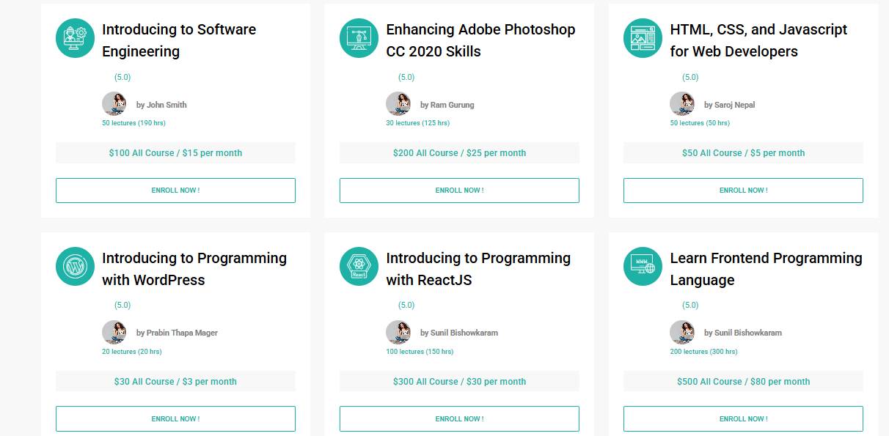





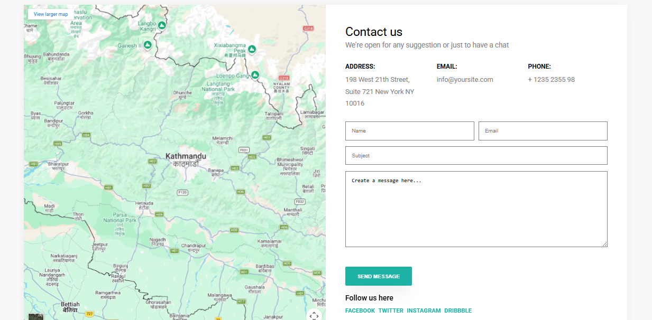

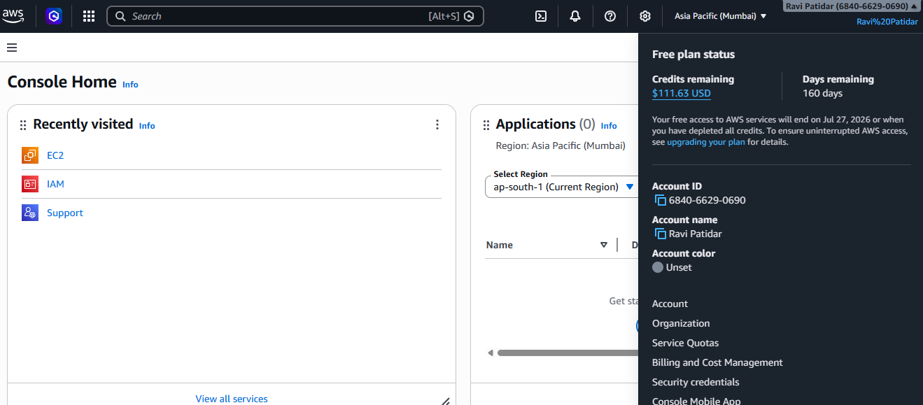

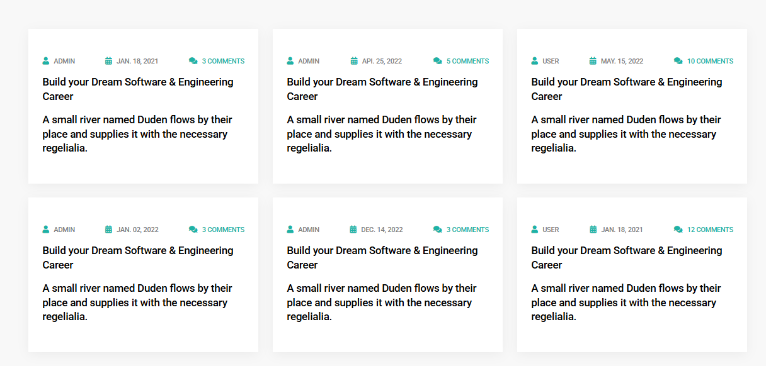

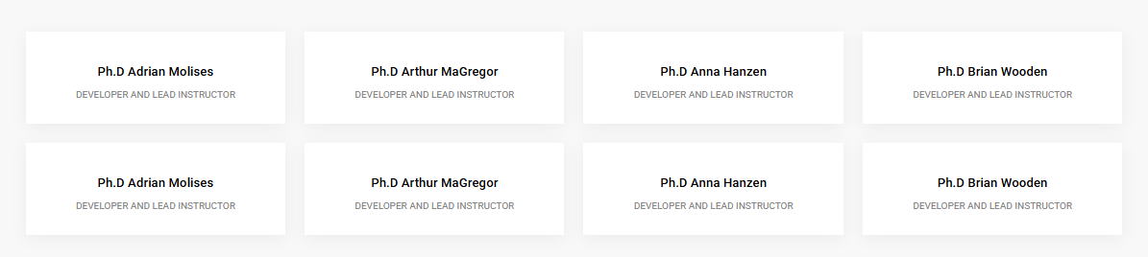



- Outputs –

The final output of this project is a successfully deployed and fully functional Online Education React application running on a Kubernetes cluster using Minikube, which demonstrates a reliable, scalable, and zero-downtime deployment system. The application was first containerized using Docker, and the Docker image was deployed on Kubernetes using Deployment configuration, resulting in multiple running pods that ensured high availability and continuous access for users. The Kubernetes Service was configured successfully, which exposed the application and allowed users to access the Online Education website through a web browser using the Minikube service URL. The application was able to handle deployment updates efficiently using the Rolling Update strategy, where new versions of the application were deployed without stopping the running service, ensuring zero downtime and uninterrupted user experience. The Kubernetes cluster also demonstrated scalability by allowing the number of application instances to be increased or decreased as required. Additionally, the self-healing feature of Kubernetes ensured that any failed container was automatically restarted, maintaining continuous system operation. The successful display and functioning of the Online Education website in the browser confirmed that the deployment process was completed correctly. Overall, the project output is a containerized, scalable, highly available, and continuously running Online Education application that can be accessed by users, updated without downtime, and managed efficiently using Docker and Kubernetes.

- Reports / dashboards / models –

This project includes various reports and dashboards that help in monitoring, managing, and verifying the successful deployment and operation of the Online Education React application on the Kubernetes cluster. The Kubernetes Dashboard provided a graphical user interface to monitor the cluster, where details such as running pods, deployments, replica status, and services were visible, confirming that the application was deployed and running successfully. The kubectl command-line reports, such as the output of kubectl get pods, kubectl get deployments, and kubectl get services, provided detailed information about the status, availability, and health of the application containers and Kubernetes resources. These reports helped in verifying that the required number of replicas were running and that the service was properly exposing the application. The Docker reports, such as the output of the docker images command, confirmed the successful creation and availability of the Docker image used for deployment. The Minikube dashboard and service reports also provided information about the cluster status and application access URL. In addition, version control reports from Git showed the application source code history and updates, while CI/CD pipeline dashboards from tools such as GitHub Actions or Jenkins, if implemented, displayed the automated build and deployment process, including build status and deployment success. These dashboards and reports helped in monitoring application performance, verifying deployment success, and ensuring that the application was running reliably and efficiently within the Kubernetes environment.

- Key outcomes –

The key outcome of this project is the successful deployment and management of the Online Education React application using Docker and Kubernetes, resulting in a scalable, reliable, and automated application deployment system. The project achieved containerization of the application, which ensured consistent performance across different environments and simplified the deployment process. It also successfully implemented Kubernetes orchestration, which allowed efficient management of application containers, maintained multiple running replicas for high availability, and ensured continuous service access for users. One of the most important outcomes was the implementation of zero-downtime deployment using the Rolling Update strategy, which enabled seamless application updates without interrupting the user experience. The project also demonstrated scalability by allowing the application to handle varying user traffic efficiently and showed fault tolerance through Kubernetes self-healing features that automatically restarted failed containers. Additionally, the application was successfully exposed through Kubernetes Service and accessed through a web browser, confirming proper deployment and functionality. Overall, the project resulted in a fully functional, highly available, scalable, and continuously running Online Education application while providing practical knowledge and hands-on experience with Docker, Kubernetes, and modern DevOps deployment practices.

Conclusion -

The project was successfully completed by designing, containerizing, and deploying the Online Education React application using Docker and Kubernetes, which demonstrated an efficient, reliable, and modern approach to application deployment and management. The application was first developed using React to provide a responsive and user-friendly interface, and then it was containerized using Docker so that the application along with its dependencies could be packaged into a single portable unit. This ensured consistency across different environments and simplified the deployment process. The containerized application was then deployed on a Kubernetes cluster using Minikube, which provided a powerful platform for container orchestration, allowing automated deployment, management, and monitoring of the application. Kubernetes Deployment was used to maintain multiple replicas of the application, ensuring high availability and continuous service even if one instance failed. Kubernetes Service was configured to expose the application and provide a stable network endpoint, which allowed users to access the Online Education platform through a web browser successfully.
The project was successfully completed by designing, containerizing, and deploying the Online Education React application using Docker and Kubernetes, which demonstrated an efficient, reliable, and modern approach to application deployment and management. The application was first developed using React to provide a responsive and user-friendly interface, and then it was containerized using Docker so that the application along with its dependencies could be packaged into a single portable unit. This ensured consistency across different environments and simplified the deployment process. The containerized application was then deployed on a Kubernetes cluster using Minikube, which provided a powerful platform for container orchestration, allowing automated deployment, management, and monitoring of the application. Kubernetes Deployment was used to maintain multiple replicas of the application, ensuring high availability and continuous service even if one instance failed. Kubernetes Service was configured to expose the application and provide a stable network endpoint, which allowed users to access the Online Education platform through a web browser successfully.

Future Scope & Enhancements -

The future scope of this project is very broad, as the current implementation focuses mainly on deploying the Online Education React application in a local Kubernetes environment using Minikube for development and learning purposes. In the future, this project can be extended by deploying the application on a cloud-based Kubernetes platform such as Amazon Elastic Kubernetes Service (EKS), Microsoft Azure Kubernetes Service (AKS), or Google Kubernetes Engine (GKE). Deploying on cloud infrastructure will make the application accessible globally, improve availability, and allow it to support real-world users. Cloud deployment will also provide advanced features such as automatic scaling, load balancing, and better resource management, which will enhance the overall performance and reliability of the system.

Another important enhancement would be the integration of a backend and database system to make the Online Education platform fully functional and dynamic. Currently, the project focuses mainly on the frontend deployment, but in the future, backend technologies such as Node.js, Spring Boot, or Django can be integrated to handle business logic, user authentication, course management, and other functionalities. A database such as MySQL, MongoDB, or PostgreSQL can be added to store user data, course details, and other important information. This will transform the project into a complete full-stack application capable of handling real-time user interactions and data management.

The project can also be enhanced by implementing advanced Continuous Integration and Continuous Deployment (CI/CD) pipelines using tools such as Jenkins, GitHub Actions, or GitLab CI/CD. This will automate the entire process of building, testing, and deploying the application whenever changes are made to the source code. Automation will reduce manual effort, improve deployment speed, and ensure faster delivery of updates. Additional testing stages such as unit testing, integration testing, and security testing can also be included in the pipeline to improve application quality and reliability.

Another future enhancement is the implementation of advanced monitoring and logging tools such as Prometheus and Grafana for monitoring system performance and application health. These tools can provide real-time insights into CPU usage, memory consumption, network activity, and application performance. Logging tools such as the ELK Stack (Elasticsearch, Logstash, and Kibana) can be integrated to collect and analyze logs, which will help in identifying and troubleshooting issues quickly. This will improve system maintenance and reliability.

Security can also be improved in the future by implementing Kubernetes security best practices such as Role-Based Access Control (RBAC), network policies, secrets management, and secure container images. Secure authentication and authorization mechanisms can be added to protect user data and prevent unauthorized access. HTTPS and SSL certificates can also be configured to ensure secure communication between users and the application.

Another important future enhancement is the implementation of automatic scaling using Kubernetes Horizontal Pod Autoscaler, which can automatically increase or decrease the number of running containers based on CPU usage or user traffic. This will ensure efficient resource utilization and maintain application performance during high traffic periods.

The project can also be enhanced by implementing a microservices architecture, where different components of the Online Education platform such as user management, course management, and payment systems are deployed as separate services. This will improve scalability, flexibility, and maintainability of the system.

In addition, a custom domain name and DNS configuration can be added to make the application more professional and accessible through a user-friendly URL. The user interface can also be enhanced by adding more features such as video streaming, live classes, quizzes, progress tracking, and user dashboards to improve the learning experience.

Overall, the future scope of this project includes transforming it into a complete production-ready Online Education platform by deploying it on cloud infrastructure, integrating backend and database systems, implementing CI/CD automation, adding monitoring and security features, enabling automatic scaling, and improving application functionality and user experience. These enhancements will make the system more robust, scalable, secure, and suitable for real-world deployment while providing advanced learning opportunities in modern DevOps and cloud technologies.

